eCMS MANUAL

Duty Free Quota

Department of Revenue and Customs
Ministry of Finance
Table of Contents
1
ECMS FE 1

ECMS FE
Onto the eCMS web page under the eCMS e-Services

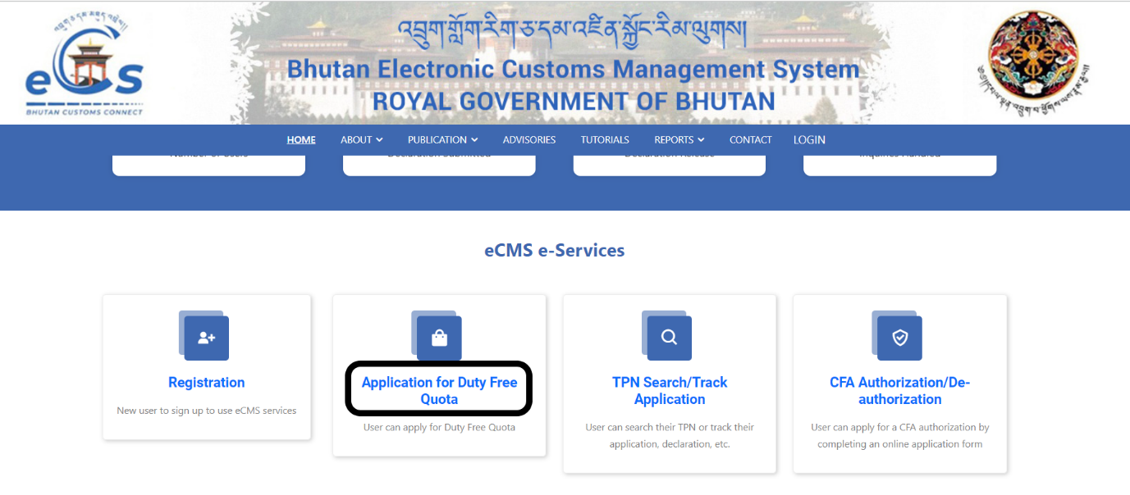

- Click on to Application for Duty Free Quota
- Fill in the details required to apply for the quotation.
  - Application Details: details of the applicant and the quota application
  - Supporting Document: required document for the application.
  - Summary: summary of the application and submit.

